Chat App

By María Ramalleira

|  |  |
| --- | --- |
| A1 | yes |
| A2 | no |
| A3 | no |
| A4 | yes |
| A5 | No |
| A6 | no |
| A7 | no |
| A8 | no |

|  |  |
| --- | --- |
| A9 | No |
| A10 | No |
| A11 | No |
| A12 | No |
| A13 | Yes |
| A14 | Yes |

Data Bases

The red circles are the primary keys, and the blue ones are the foreign keys.

This is the result of the Data Bases, as you can see users has one primary key, which is the id from each user, and the messages table has two foreign keys, both are user’s ids.

SCREEN MAP:

The first thing that appears in my web is the login, where some validations are made to see if the credentials are correct or not.

In the right bottom corner, we have the Sign up link that will redirect us to the sign up page:

If the user credentials are wrong he would wet a warning, and he would have to insert them again.

In the sign up part, the user has to introduce the email, and also the password which will be hashed and insert in the data bases.

You could sumbit your credentials or reset them, if the email is already used it would give you a warning.

Also you can go to the login page from this one.

For example if I create a new user the data bases is modified:

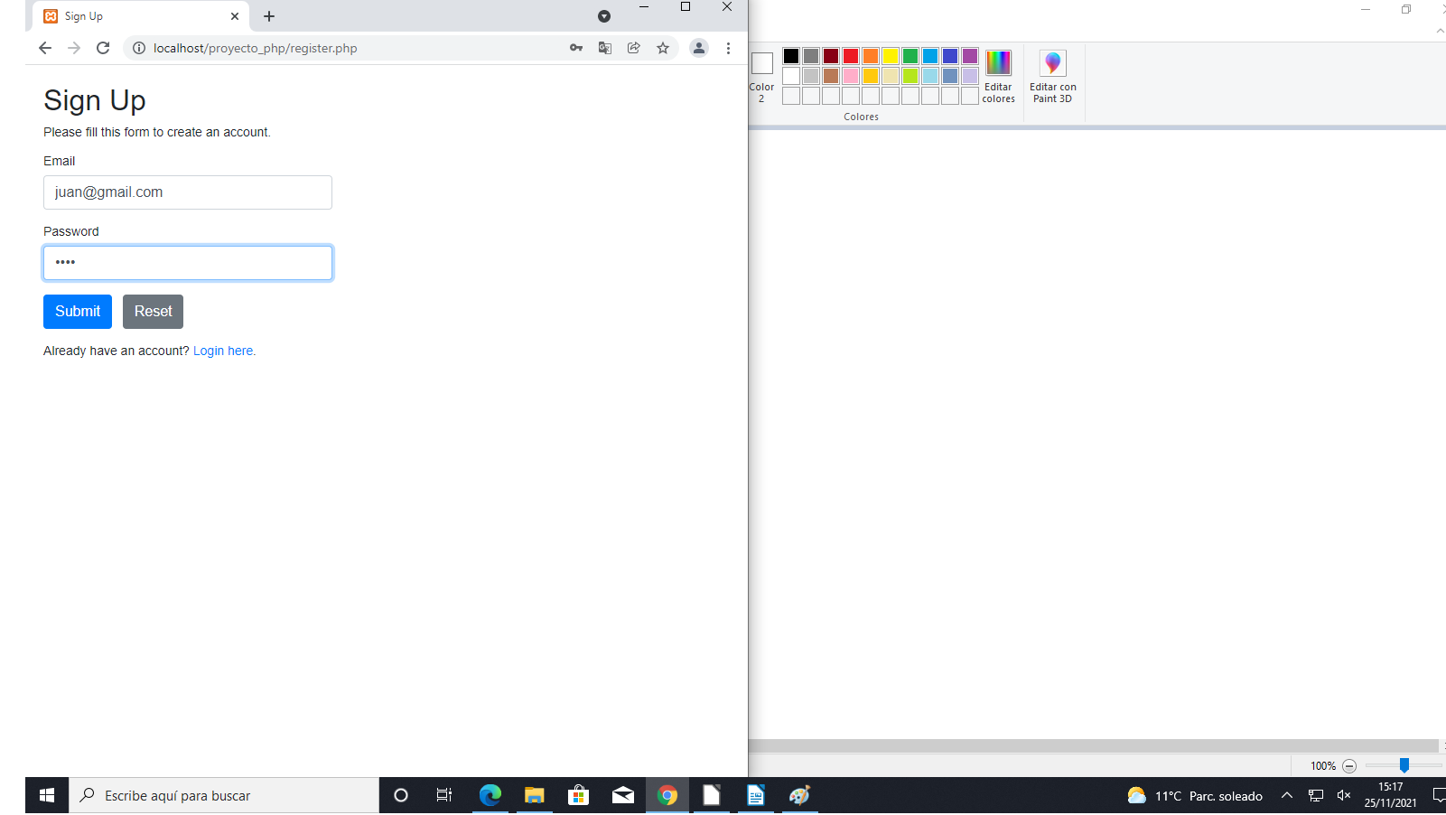

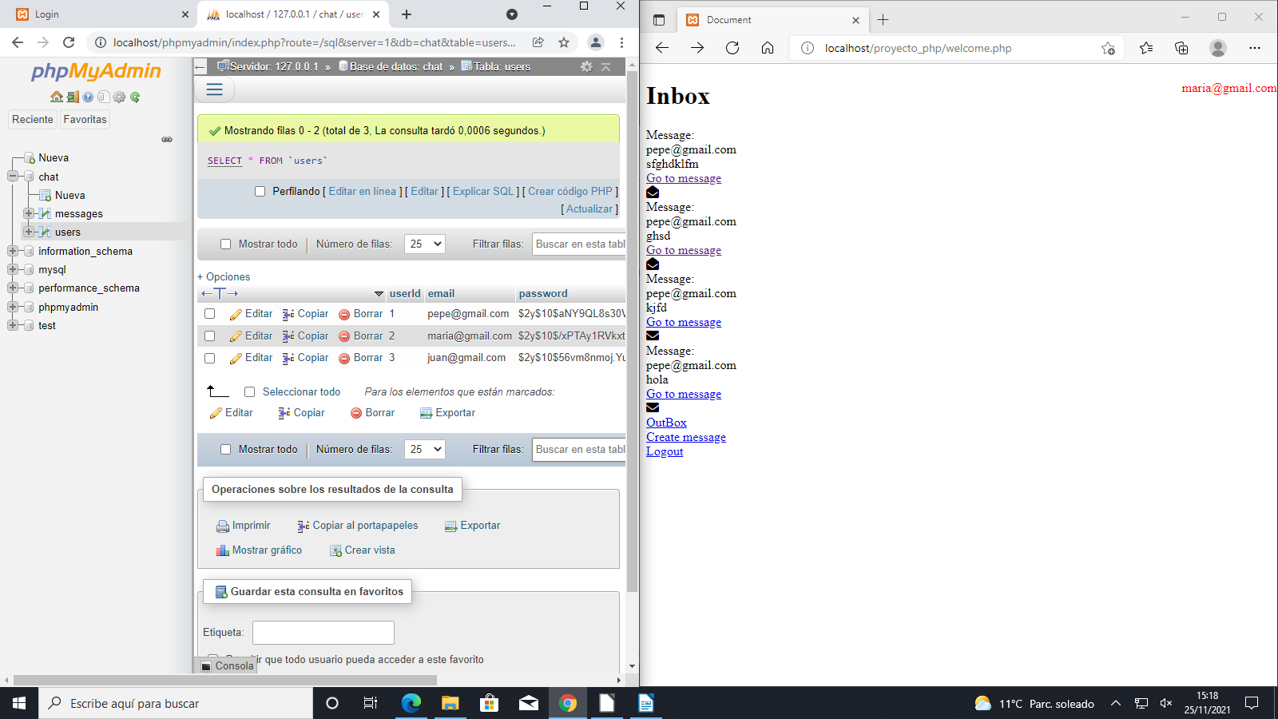

If you write an username instead of an email you would get also a warning:

And also if the email is already used:

When you are logged you enter to the welcome page, in this case the inbox of the user, here appears the different messages the user has received.

The second message is from Pepe, and it shows the subject of the message, if you click on go to the message you will see all the information that it contains; the text, the timestamp…

The envelope helps the user to know if he has read the message, when the envelope is opened, or when he has not, when the envelope is closed.

When you click on go to message you have the option to answer from the same page, then you can go to the main page or logout.

On the right side of each pages is the email of the user that is logged.

If we click on the outbox link, we will see all the messages the user has sent, with some information:

Who has the message been send to and the subject.

We can click in go to message to see more information

This is the message, as you can see the only thing that changes is that you can see more information; the text, the date, and if the reciever has read the message or not.

When you create a new message

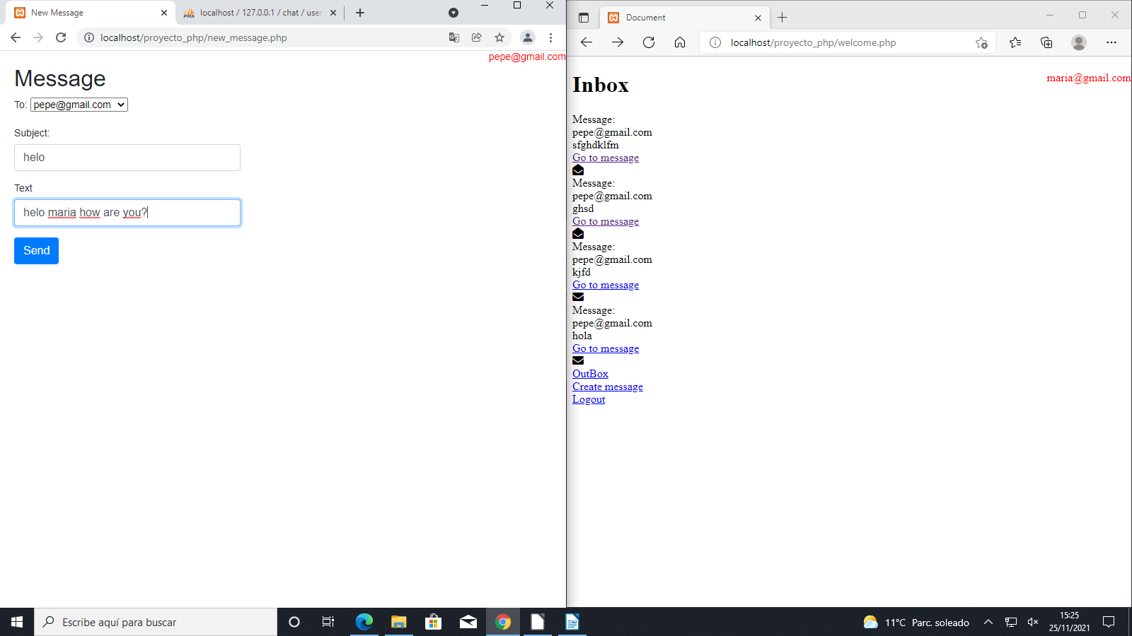

A new message will be created in the data bases

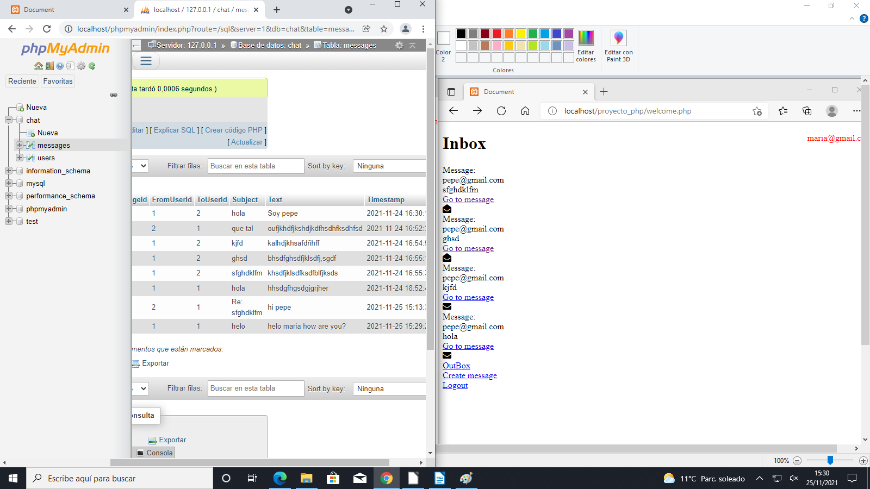

You always can return to the last page or to the main one that is the inbox.

This app is simple, but it works well.

The extensions that I chose were the A1 which is about the register, as you can see in the photo you can register properly but it doesn’t send the link to activate it.

The next one is the A4, the hashed password:

As you can see all the passwords are hashed when they are insert in the data bases, and this is how I did it:

With the function password_hash() and the PASSWORD_DEFAULT it is done.

And when you have to write the password on the login obviously it has to be the normal one, not the hashed, that was one of the problems I had at the beginning, the password I was saving in my session was the hashed one.

The next extension I chose was the Outbox:

And when you click on go to message, you will see the message body, the timestamp and also if the receiver has read the message.

The last extension I chose was the presentation in class.

The User manual:

The first thing you must do, is to import the databases on your phpMyAdmin and see if the insert has been done successfully.

There are few users and messages already created.

[maria@gmail.com](mailto:maria@gmail.com) – 1234

[pepe@gmail.com](mailto:pepe@gmail.com) - 1234

[admin@gmail.com](mailto:admin@gmail.com) – admin

[juan@gmail.com](mailto:juan@gmail.com) - 1234

After that you have to open the login.php in the local host in google, when it is open, you have to introduce the credentials that are in the data bases, for example [maria@gmail.com](mailto:maria@gmail.com) and the password you can’t see it in the data bases because it is hashed, but is 1234 for all the users except for the admin user that is admin.

The admin user was for the admin extension, but I didn’t have enough time, so I couldn’t finish it.

You also can create a new user if you want in the sign-up page, were you should write a new email that is not in the data bases, and a password which would be hashed.

After that you would be redirected to the login page

In the inbox you have different options; to see the messages you have received, to create a new message, to replay a message, to go to the outbox, or to logout.

When you create a new message, and you send it you are redirected to the main page that is the inbox page.

In the Inbox you can see an envelope, this helps you to see if you have opened that message or if you haven’t.